AWS WAF

AWS WAF is a web application firewall that lets you monitor the HTTP and HTTPS requests that are forwarded to your protected web application resources. You can protect the following resource types:
- Amazon CloudFront distribution
- Amazon API Gateway REST API
- Application Load Balancer
- AWS AppSync GraphQL API
- Amazon Cognito user pool
- AWS App Runner service
- AWS Verified Access instance
- AWS Amplify
AWS WAF lets you control access to your content. Based on conditions that you specify, such as the IP addresses that requests originate from or the values of query strings, your protected resource responds to requests either with the requested content, with an HTTP 403 status code (Forbidden), or with a custom response.

Request Processing Flow
- A request arrives at a protected resource such as:
  - Amazon CloudFront
  - Application Load Balancer
  - Amazon API Gateway
  - AWS AppSync
- AWS WAF evaluates the request against a Web ACL (Access Control List).
- Rules are processed in priority order:
  - Custom rules
  - Managed rule groups
  - Rate-based rules
  - IP/Geo restrictions
  - Bot protection rules
- When a rule matches, AWS WAF performs the configured action:
  - Allow – Request proceeds to the application.
  - Block – Returns HTTP 403 (or a custom response).
  - Count – Logs the match but allows the request.
  - CAPTCHA – Requires the client to solve a challenge.
  - Challenge – Performs a silent browser verification.
Example
Rule | Action
Block traffic from 1.2.3.4 | Block
Block SQL Injection patterns | Block
Rate limit > 1000 requests/5 min | Block
Default action | Allow

Default Action
Every Web ACL must have a default action:
- Allow (common)
- Block (zero-trust approach)
If no rule matches, the default action is applied

Rule Priority
Rules are evaluated from lowest priority number to highest. Once a terminating action (Allow/Block) is reached, evaluation stops.

Rate-Based Rules
AWS WAF can automatically block or challenge clients that exceed a request threshold within a rolling 5-minute window

Managed Rules
AWS provides managed rule sets for:
- SQL Injection (SQLi)
- Cross-Site Scripting (XSS)
- Known bad inputs
- Bot traffic
- Account takeover protection

Logging and Visibility
AWS WAF can:
- Log requests
- Show matched rules
- Publish metrics to Amazon CloudWatch
- Help analyze attack patterns and false positives
Getting started with AWS WAF

Step 1: Set up AWS WAF
If you haven't already followed the general setup steps in Setting up your account to use the services, do that now.

Step 2: Create a protection pack (web ACL)
In this step, you'll create a protection pack (web ACL) and configure its basic settings to match your application type.
- Sign in to the new AWS Management Console and open the AWS WAF console at https://console.aws.amazon.com/wafv2-pro.
- In the navigation pane, choose Resources & protection packs (web ACLs).
- On the Resources & protection packs (web ACLs) page, choose Add protection pack (web ACL).
- Under Tell us about your app, for App category, select one or more app categories that best describe your application.
- For Traffic source, choose the type of traffic your application handles:
  - API - For API-only applications
  - Web - For web-only applications
  - Both API and Web - For applications that handle both types of traffic

Step 3: Add resources to protect
Now you'll specify which AWS resources to protect with your protection pack (web ACL).
- Under Resources to protect, choose Add resources.
- Choose the category of AWS resource to associate with this protection pack (web ACL):
  - Amazon CloudFront distributions
  - Regional resources
For more information about resource types, see Associating protection with an AWS resource.

Step 4: Choose initial protections
In this step, you'll select the rules for your protection pack (web ACL). For first-time users, we recommend choosing the Recommended option.
AWS WAF generates Recommended for you based on your selections in the Tell us about your app section. These packs implement security best practices for your application type.
- Choose Next to continue with the protection pack (web ACL) setup.

Step 5: Customize protection pack (web ACL) settings
Now you'll configure additional settings like default actions, rate limits, and logging.
- Under Name and description, enter a name for your protection pack (web ACL). Optionally, enter a description.
- Under Customize protection pack (web ACL), configure the following settings:
  - Under Default rule actions, choose the default action for requests that don't match any rules. For more information, see Customized web requests and responses in AWS WAF.
  - Under Rule configuration, customize these settings:
    - Default rate limits - Set limits to protect against DDoS attacks
    - IP Addresses - Configure IP allow/block lists
    - Country specific origins - Manage access by country
  - For Logging destination, configure where you want to store logs. For more information, see AWS WAF logging destinations.
- Review your settings and choose Add protection pack (web ACL).

Step 6: Clean up your resources
You've now successfully completed the tutorial. To prevent your account from accruing additional AWS WAF charges, you should either delete the protection pack (web ACL) you created or modify it to match your production needs.

To delete your protection pack (web ACL)
- In the navigation pane, choose Resources & protection packs (web ACLs).
- Select the protection pack (web ACL) you created.
- Choose the trash icon, then confirm the deletion by typing "delete".
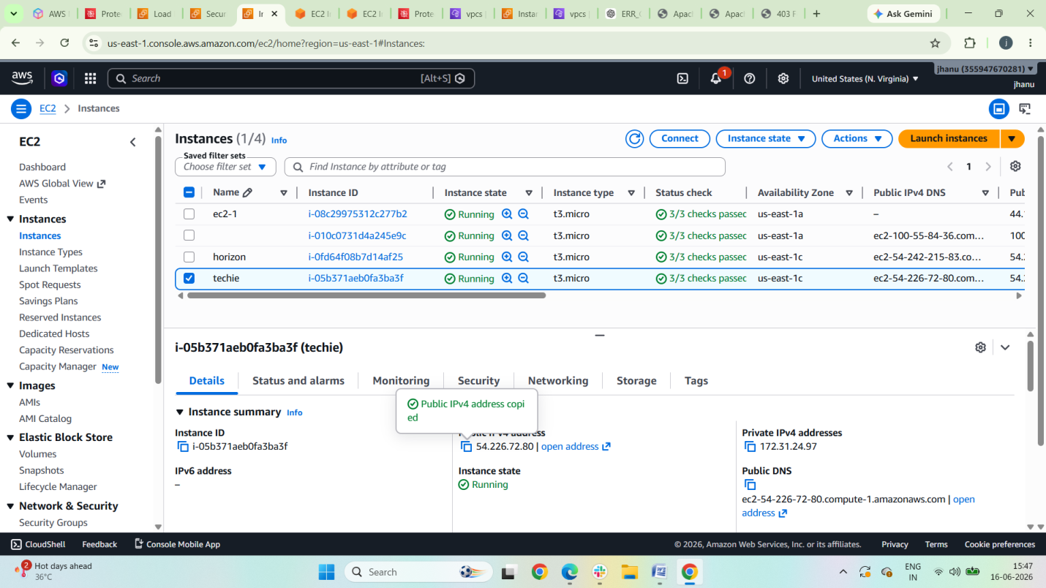

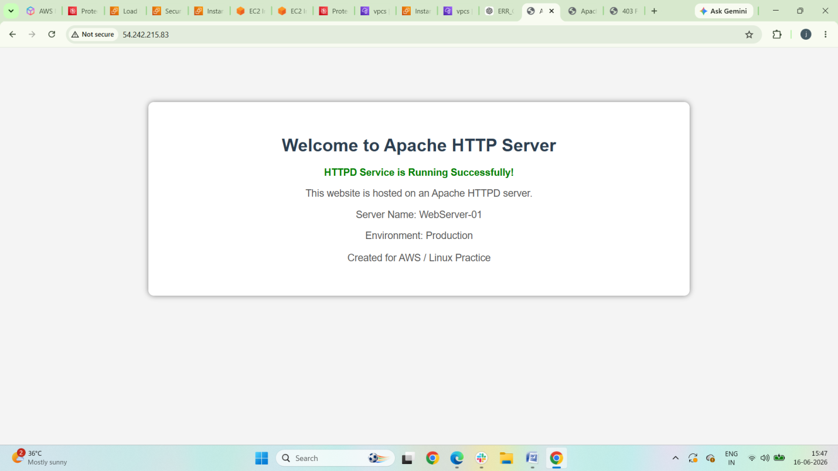

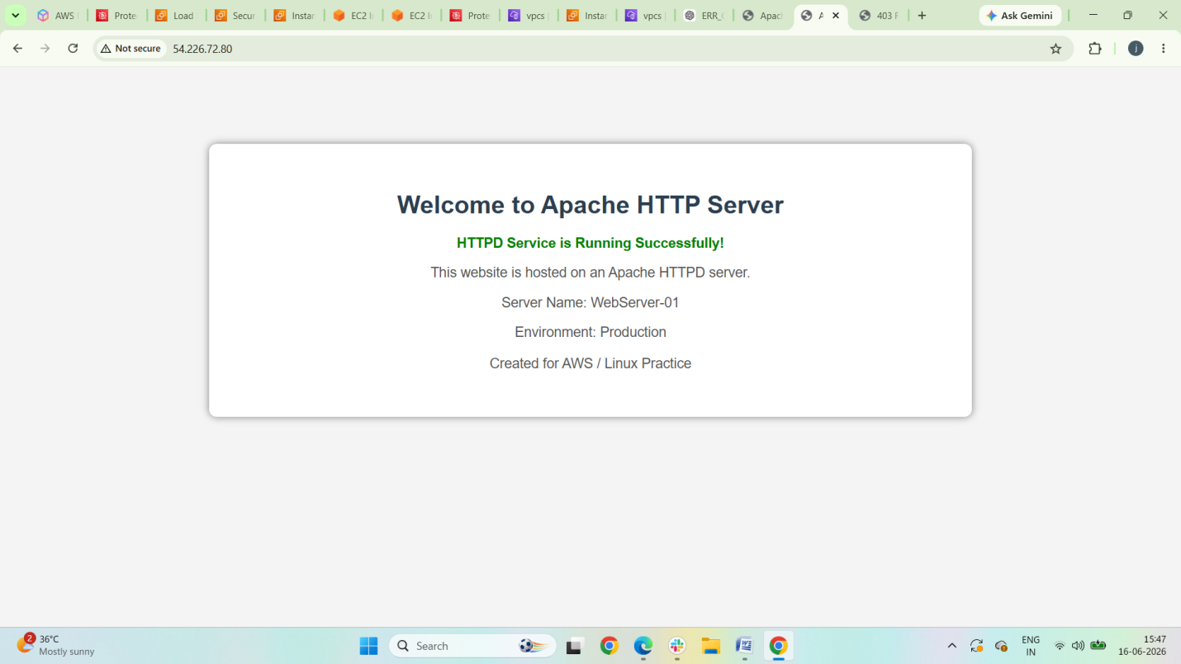

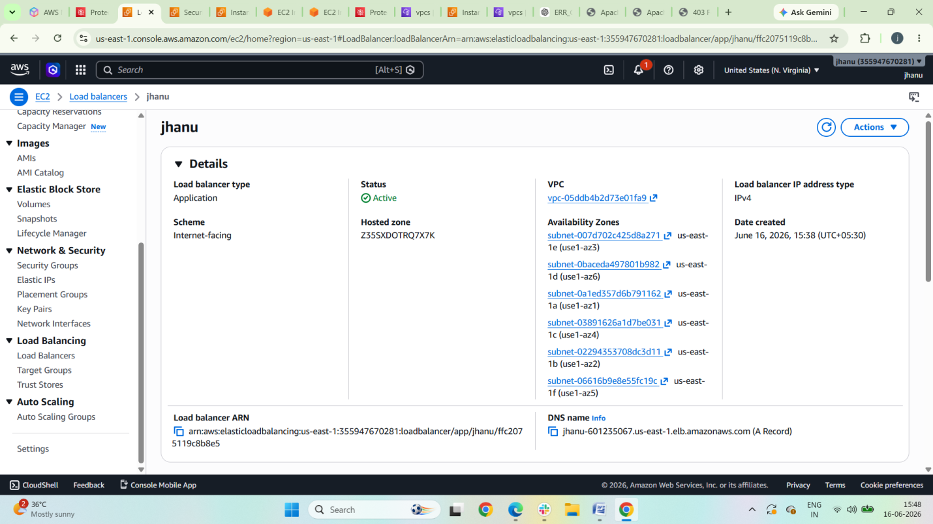

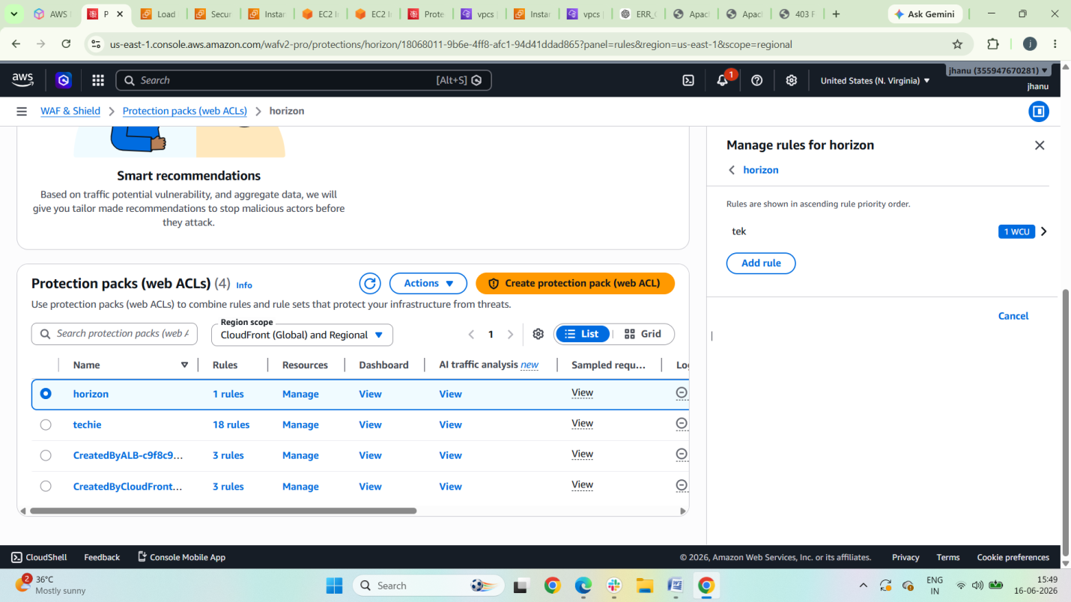

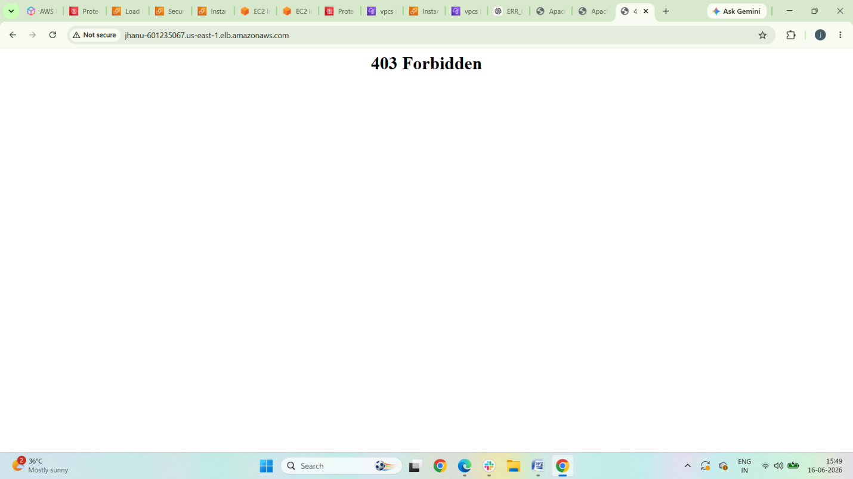

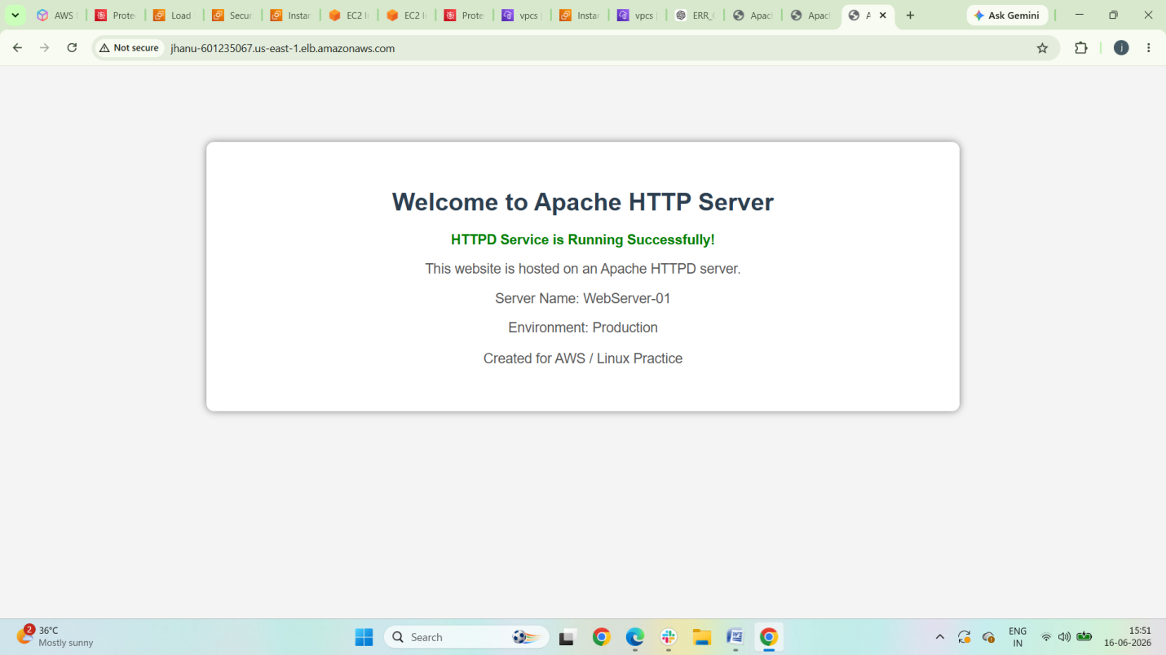

AWS Systems Manager

AWS Systems Manager (SSM) is an AWS service that helps you manage, automate, and operate your AWS infrastructure and applications across AWS accounts, Regions, and even on-premises servers.

Key Features
- Session Manager
  - Secure shell access to EC2 instances without opening SSH (port 22) or RDP (port 3389).
  - Access instances through the AWS Console, CLI, or SDK.
  - Supports session logging to CloudWatch or S3.
- Parameter Store
  - Centralized storage for configuration data and secrets.
  - Supports plain text and encrypted values (using KMS).
  - Commonly used for database credentials, API keys, and application settings.
- Run Command
  - Execute commands remotely on managed instances at scale.
  - No need to log into each server individually.
  - Useful for patching, configuration updates, and diagnostics.
- Patch Manager
  - Automates OS patching for EC2 instances and on-premises servers.
  - Supports patch baselines and maintenance windows.
- Automation
  - Run predefined workflows (runbooks) to automate operational tasks.
  - Examples: restart instances, create AMIs, remediate security issues.
- Inventory
  - Collect metadata about managed nodes.
  - Track installed software, OS versions, network settings, and more.
- State Manager
  - Maintain desired configurations across instances.
  - Similar to configuration management tools.
- Maintenance Windows
  - Schedule administrative tasks during approved time periods.

  - Works with Run Command, Automation, Lambda, and Step Functions.

How It Works
To manage an EC2 instance with Systems Manager:
- Install or use the preinstalled SSM Agent.
- Attach an IAM role containing permissions such as AmazonSSMManagedInstanceCore.
- Ensure connectivity to Systems Manager endpoints (Internet, NAT Gateway, or VPC endpoints).
- The instance appears as a managed node in Systems Manager.

Common Interview Question
Q: What are the advantages of Session Manager over SSH?
- No inbound security group rules required.
- No SSH key management.
- Centralized access control through IAM.
- Session logging and auditing.
- Works through AWS APIs and the AWS Console.

Typical Architecture
Administrator
|
v
AWS Systems Manager
|
v
SSM Agent on EC2 / On-Prem Servers
|
v
Managed Instances

Common Use Cases
- Secure server access without bastion hosts.
- Centralized secret management.
- Automated patching and compliance.
- Fleet-wide command execution.
- Operational automation and remediation.

main features of Systems Manager

Feature | Purpose
Session Manager | Securely connect to EC2 instances without SSH or RDP.
Run Command | Execute commands on one or multiple managed instances remotely.
Parameter Store | Store configuration data, passwords, API keys, and secrets securely.
Patch Manager | Automate operating system patching and compliance.
Automation | Automate common maintenance and operational tasks using runbooks.
State Manager | Maintain desired configurations on managed instances.
Inventory | Collect metadata about instances, installed software, and configurations.
Maintenance Windows | Schedule administrative tasks such as patching and updates.
Fleet Manager | Manage and troubleshoot Windows and Linux servers from a single console.
Distributor | Package and distribute software to managed instances.
OpsCenter | Central location to investigate and resolve operational issues.
Explorer | Provides an aggregated view of operational data across AWS resources.
Incident Manager | Helps prepare for and respond to operational incidents.
Application Manager | View and manage application resources and operations.

Most Commonly Used Features in Real Projects
- Session Manager – Secure access to EC2 instances.
- Parameter Store – Store application configurations and secrets.
- Run Command – Execute scripts across multiple servers.
- Patch Manager – Automate OS patching.
- Automation – Automate operational workflows.
- State Manager – Enforce desired server configurations.

Benefits
- No need to open SSH (22) or RDP (3389) ports.
- Centralized server management.
- IAM-based access control.
- Auditing and logging through CloudWatch and S3.
- Supports AWS, on-premises, and hybrid environments.

General setup for AWS Systems Manager

Create an IAM Role for EC2
Attach the AWS-managed policy:
AmazonSSMManagedInstanceCore
IAM Console
- Go to IAM → Roles → Create Role.
- Select AWS Service → EC2.
- Attach policy:
  - AmazonSSMManagedInstanceCore
- Create the role (e.g., SSM-EC2-Role).

2. Attach the IAM Role to the EC2 Instance
- Go to EC2 Console.
- Select the instance.
- Actions → Security → Modify IAM Role.
- Attach the SSM-EC2-Role.

3. Verify SSM Agent
Most modern Amazon Linux, Ubuntu, and Windows AMIs come with the SSM Agent preinstalled.

Check on Linux
sudo systemctl status amazon-ssm-agent
Start the agent if necessary:
sudo systemctl start amazon-ssm-agent
sudo systemctl enable amazon-ssm-agent

Check on Windows
Get-Service AmazonSSMAgent

4. Ensure Network Connectivity
The instance must reach Systems Manager endpoints.

Option A: Internet Access
- Public subnet + Internet Gateway
- OR Private subnet + NAT Gateway

Option B: Private Access (Recommended)
Create VPC Endpoints:
- com.amazonaws.<region>.ssm
- com.amazonaws.<region>.ec2messages
- com.amazonaws.<region>.ssmmessages
Example:
VPC
├── EC2 Instance
├── SSM Endpoint
├── EC2Messages Endpoint
└── SSMMessages Endpoint

5. Verify Managed Instance Registration
Go to:
AWS Systems Manager → Fleet Manager
or
Systems Manager → Managed Nodes
Your instance should appear with:
Ping status: Online

6. Test Session Manager
From the AWS Console:
- EC2 → Select Instance.
- Connect.
- Session Manager.
- Connect.
Or using AWS CLI:
aws ssm start-session \
--target i-0123456789abcdef0

7. Enable Session Logging (Optional)
Store session logs in:
- Amazon CloudWatch Logs
- Amazon S3
Systems Manager → Session Manager → Preferences

8. Test Run Command
Example:
aws ssm send-command \
--document-name "AWS-RunShellScript" \
--targets "Key=instanceids,Values=i-0123456789abcdef0" \
--parameters commands=["hostname","uptime"]

Architecture
Administrator
|
v
AWS Systems Manager
|
v
SSM Service
|
v
SSM Agent
|
v
EC2 Instance

Prerequisites Checklist
✅ EC2 instance running
✅ IAM role with AmazonSSMManagedInstanceCore
✅ SSM Agent installed and running
✅ Network access to SSM endpoints
✅ Instance appears as a Managed Node

